Chapter 3.
Fungal Growth

This chapter will describe how fungi can grow and obtain nutrients from the surrounding environment. Fungi are unique organisms that have features not found elsewhere in biology. Therefor it is important as cultivators to understand how fungi grow in hope of encouraging growth of beneficial fungi while inhibiting the growth and presence of fungal pathogens.

There are two main types of growth forms that fungi display; filamentous and yeast. The body of filamentous fungi is made of thin, thread-like, typically cylindrical cells that are extensively branched called hyphae (sing. hypha). These cells allow filamentous fungi to penetrate through substrates. All of the hyphae from an individual fungus is collectively called mycelium (plural mycelia when referring to more than one fungal individual). The mycelium is the vegetative body of the fungus and is the necessary form for the filamentous fungi to collect nutrients and water (see Fig. 1).
Yeast are single celled fungi, usually spherical, that do not form hyphae. Some fungi can take on a yeast or a filamentous form, depending on the growth stage and environmental conditions. Fungi capable of this versatility in form are referred to as dimorphic.

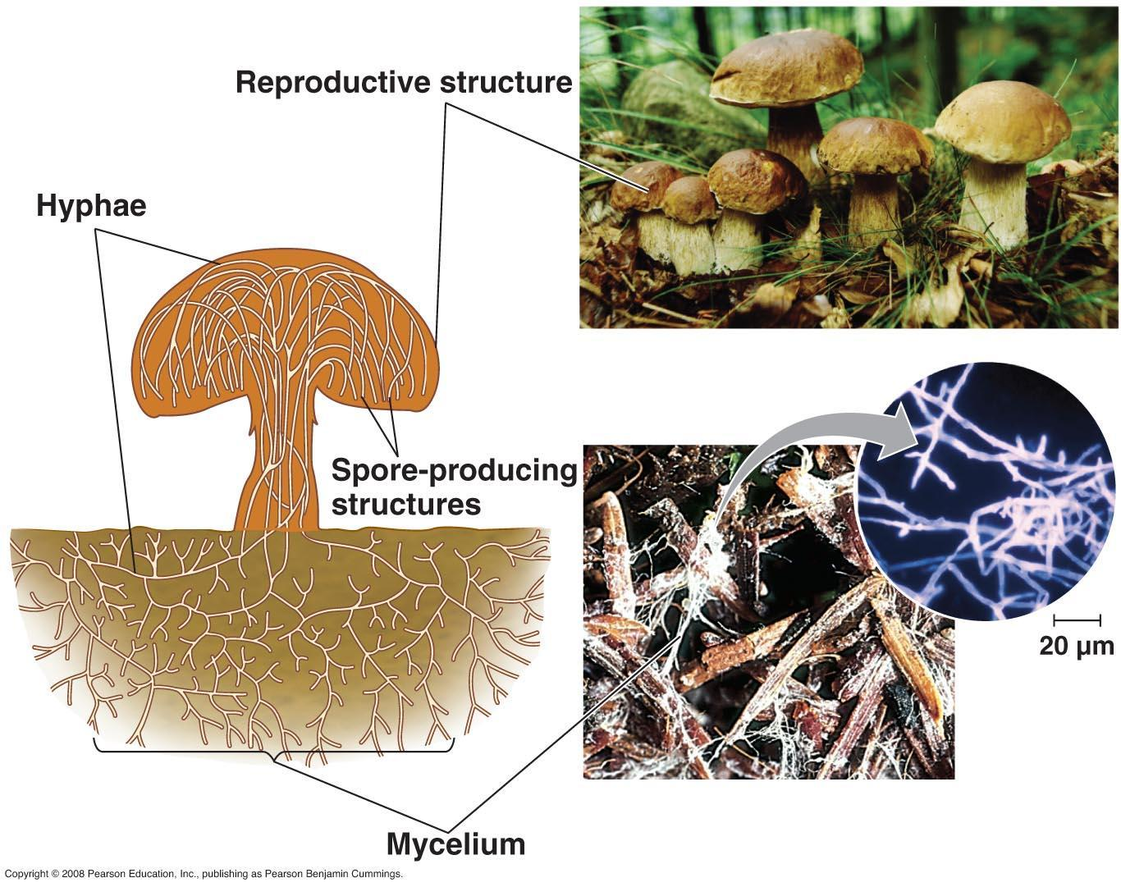
Figure 3.1. Mycelium comprises the totality of individual hyphal strands from a single fungus. Mycelium grows around and through food sources, such as the decomposing wood chips pictured. Once the proper environmental cues are received, mycelium begins to coalesce into tightly packed structures which will grow into mushrooms. The mushrooms are the part of the fungus that bear the reproductive structure where spores will be produced via meiosis. (http://biology-pictures.blogspot.com/)

Yeast forms exist as single cells that replicate via budding or fission, creating two exact genetic copies of itself from a single mother cell. In this way, vegetative growth in yeast is characterized by asexual reproduction of individual cells, rather than growth of a single contiguous hyphal body. Many yeast can also reproduce via sexual replication.

Filamentous fungi
Filamentous fungi eat and grow simultaneously. They do so by releasing enzymes ahead and out of the growing hyphal tip, then pushing through their food as they consume it. To coordinate the release of enzymes, filamentous fungi have an organelle-like structure that is called a spitzenkorper at the tip of growing hyphae (Figure 2.1). This microtubule-dense organizational center delivers vesicles full of enzymes directly outside the growing fungal tip. This external enzyme bath breaks down complex materials into more fundamental, nutritive molecules which are then accessible for endocytosis or direct absorption by the fungus (Steinberg 2014). Additionally, the breakdown of solid substrates clears a path for physical growth of and occupation by the fungus.
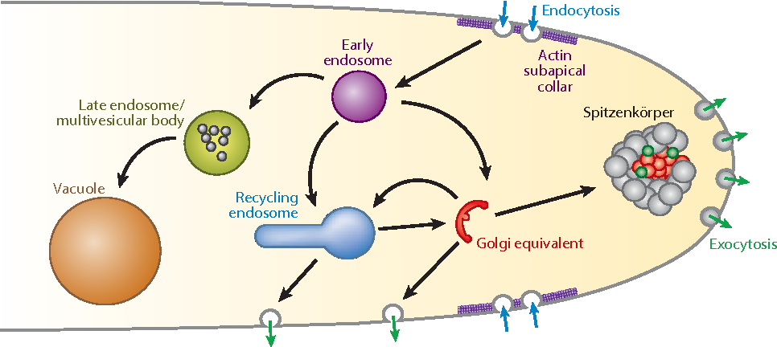
Figure 3.2. Growing fungal tip secretes enzymes and releases them into the environment (exocytosis) and then transporting smaller molecules back into the hypha for growth (endocytosis). (Riquelme 2013).

Once inside the hyphae, molecules are further broken down and metabolized by the fungus for all of its life functions and growth, including synthesizing proteins, cell walls, hormones, etc.. This is how a fungus ‘eats’, consumes resources, and grows. As the keen mycologist Tom Volk often explains, “it would be as if I went to a 5 star restaurant and ordered the surf and turf (or tofu surprise) and then when the meal came I vomited all over the dish and then stuck my hands over the mess to absorb the nutrients back into my body.” Quite the image.
Another trait that some filamentous fungi possess is having septa. Septa are crosswalls that some fungi produce behind the growing tip in order to divide the hyphae into different ‘cells’. These septa are perforated, allowing some organelles to pass while blocking others. Because many groups of fungi allow the movement of so much of their cellular contents, sometimes including nuclei, the individuality of each cell isn’t always clearcut.
There are two different types of septa that are found in fungi; simple porate septa and dolipore septa. These different septa morphologies can be used to distinguish the phylum that the fungus is located in. Fungi in the phylum Basidiomycota have what is called a dolipore septum, often along with a clamp connection. This type of septum has membranes covering the central pores, allowing for the fungus to maintain its dikaryotic state (2 types of nuclei per cell) while still allowing small organelles and chemicals to flow through with the cytoplasm. Fungi in the phylum Ascomycota have simple porate septa. These septa have no membrane to block organelles from passing from one cell to the next. Therefore, large, unbound organelles, including nuclei, are free to travel through the septa. Some groups of fungi lack any septa at all (or only have them adventitiously), including the ‘Zygomycota’ (bread molds), Glomeromycota (endomycorrhizae), and the Chytridiomycota (includes the causal agent of chytridiomycosis). When the hyphae does not have septa it is termed coenocytic or aseptate (Fig. 3.2).
The unrestricted connectivity within the body of coenocytic fungi and ascomycetes permit them to function as single, multinucleate cells. Often fungi have a high density of nuclei at the growing tip where the demand for gene products may be particularly high. Fungi can fuse with compatible fungi and exchange nuclei and cytoplasm. The resulting genomic variation among nuclei within a single fungi permits these types of fungi more phenotypic plasticity to adapt to the environment in which they are growing than would a mononucleate fungus. Transfer of nuclei, followed by recombination or chromosome donation, may also serve as an important source of genetic novelty during fungal evolution, particularly among fungi not known to undergo sexual reproduction (Roper et al, 2011). This can occur even among distantly related species.
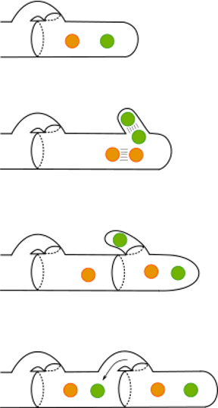
Figure 3.4. Clamp connections of a member of Basidiomycota. This feature is of Basidiomycetes and is therefore useful for identification purposes. wiki

Some filamentous fungi will produce a fruiting body collectively called a mushroom. A mushroom is simply a reproductive structure that certain fungi have evolved to produce. In general, edible mushroom producing fungi are not physiologically involved with Cannabis. However, some applications of mushroom producing species may be beneficial in Cannabis agriculture. For example, Pleurotus osreatus, the common oyster mushroom, can be cultivated on the dead biomass of Cannabis plants (the stems, the leaves). Another example of a mushroom producing fungus that aids in Cannabis cultivation is Stropharia rugosa-annulata or the garden giant (aka wine cap). This fungus is particularly good at decomposing organic materials such as wood chips or straw and is commonly inoculated in garden beds. In addition, planting mushrooms near cash crops also recruits other biology to the soil system. Using the garden giant will help aid in nutrient cycling, improve soil structure, and may release compounds that influence plants and/or soil biology. https://www.ncbi.nlm.nih.gov/pmc/articles/PMC4358370/
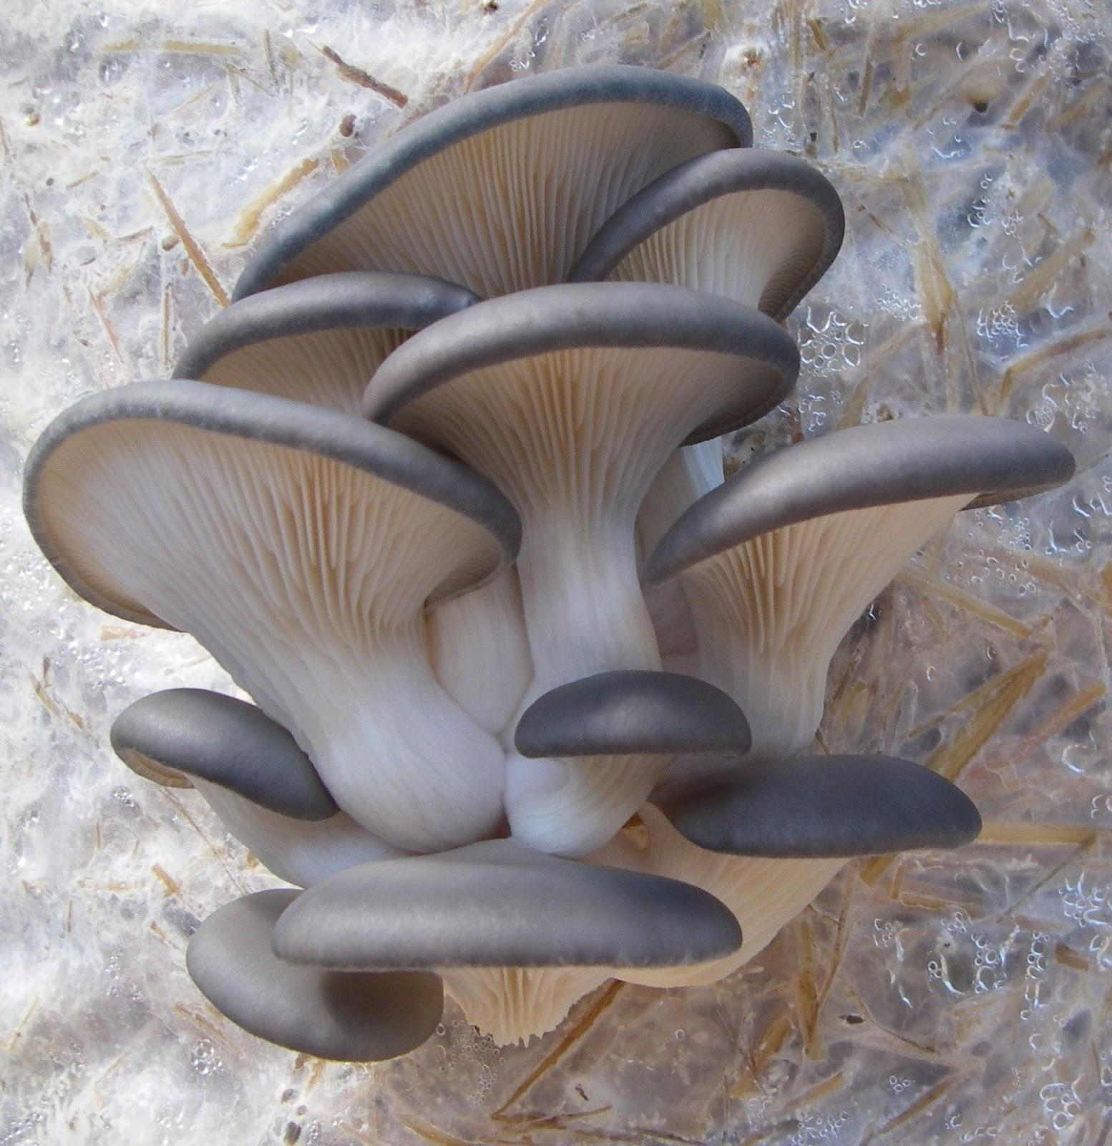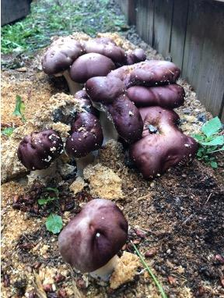
3.5a Oyster mushroom fruiting off straw. 3.5b Wine cap fruiting out of soil.
Put on 2 pages next to each other

Currently there is some misinformation going around in the Cannabis industry in relation to soil fungi and compost tea. There have been claims by some who say that if a fungus has septa, then the fungus is beneficial and will help with decomposition and plant growth. However, if the fungus does not have septa (coenocytic), then it is a pathogenic fungus and will kill plants and harm your soil community. While there are some instances where this may be true, this is a broad over-generalization and septa alone should not be used to identify beneficial vs pathogenic fungi. Possibly, what people are referring to is Oomycetes, or water molds, which are coenocytic, pathogenic, and are also not true fungi. Many useful and beneficial fungi lack septation, including members of the Glomeromycota, and Zygomycota.

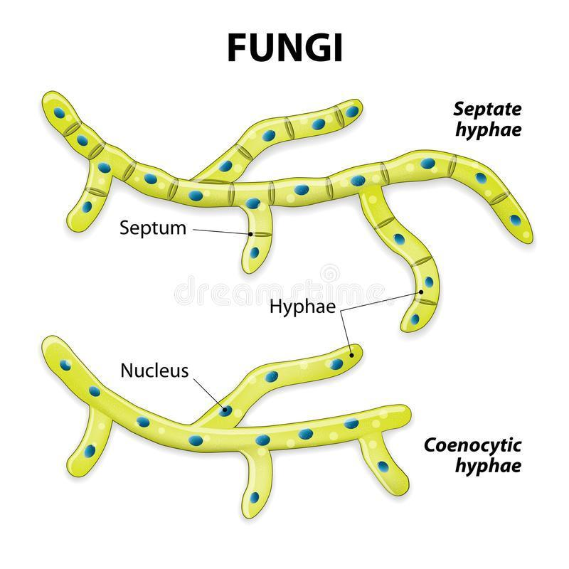
Figure 3.6. Fungal hyphae with septa (top) and without septa (coenocytic) on bottom. (dreamstime.com)

Yeast fungi
Yeasts truly are single celled fungi. An individual yeast cell is very small and cannot be seen with the naked eye. Yeasts are ubiquitous and are found throughout the world and in a range of habitats. The most famous yeast, Saccharomyces cerevisiae or the brewers yeast, is used not only to brew delightful beverages but also to bake bread. The same species (but different varieties/strains) are used for both processes. Thus, humans and yeasts have a relationship longer than written history. Saccharomyces cerevisiae is also a model organism used in scientific research. As an easily culturable and resilient eukaryote, it has proven to be extremely useful to humans on a number of counts. On the other end of the spectrum, some species of yeasts are capable of causing serious diseases among humans, including Crypotococcus neoformans, which is also a potential endophyte of Cannabis and the cause of cryptococcosis.
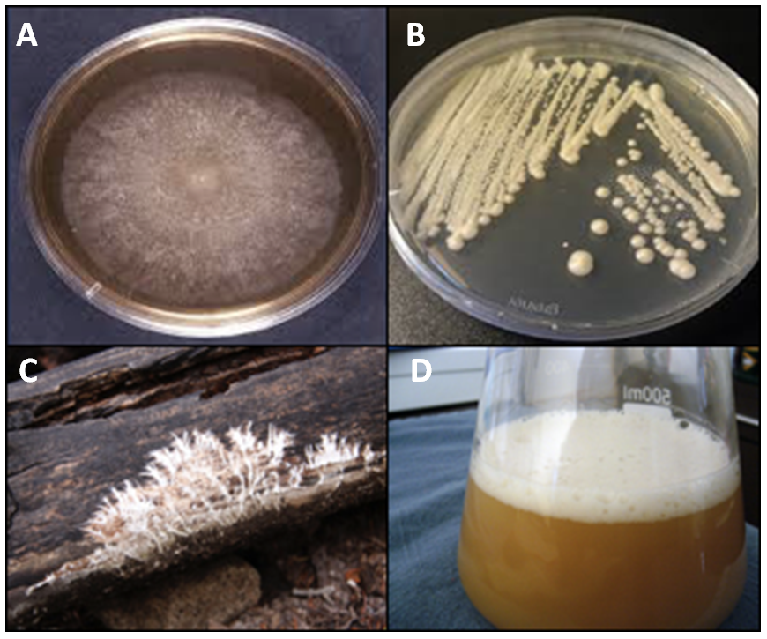
Figure 3.7. A. Filamentous fungus growing on a petri dish in a laboratory. B. Yeast being cultured on a perti dish in a laboratory. C. Filamentous fungus growing on/degrading a log (saprophytic fungus). D. Yeast being grown in liquid culture to pitch for brewing beer, (A. http://microbiologyonline.org/, B. dcylab.wordpress.com, C. eurekabrewing.wordpress.com, D. gardenoftomorrow.com).

Yeast are very difficult if not impossible to identify simply by looking at a microscope. There are some yeasts that display unique physiological traits that allow them to be identified by simple observation, but many need to be subjected to metabolic tests or, the most rigorous method of identification currently available, by using molecular techniques.
Even though yeasts may be hard to see and often go unappreciated, they too play an important role in the soil and in agriculture in general. The full role that yeasts play in soil and on above ground biomass of plants is poorly understood, but what we do know is that they are present whenever we look for them. These single-celled fungi help decompose organic matter, act as a food source for other soil life, produce novel metabolites, influence plant growth, and help shape the soil structure. Without them, the soil, and therefore the plants, would behave very differently.

Conclusions
Fungi either grow as a unicellular yeasts, have a filamentous body of hyphae collectively called mycelium, or may switch between these forms. Filamentous growth offers certain advantages over yeast forms for the performance of particular tasks. The absorptive eating strategy employed by fungi benefits from a highly branched, fast expanding body with favorable surface ratio for the exploitation of an abundant food resource. As digestive enzymes released from the growing tip of the fungus, the hyphal body can absorb the products of the substrates decomposition via endocytosis. Filamentous fungi may also differentiate into specialized structures and have complex patterns of nutrient transport and metabolic coordination. This can be particularly useful when claiming territory and food resources over long periods of time. Some filamentous fungi can grow perennial structures that persist and function for years and even decades. However, being small and simple in design has its benefits as well. Yeasts are capable of reproducing at an extraordinary rate. Because they are just a single cell, everything the organism needs to survive and reproduce is kept in every cell.
As you can see, fungi can be quite diverse in appearance both macroscopically and microscopically. While these differences have proven useful as diagnostic features for the identification and classification of organisms, the true utility of these features is to allow fungi to specialize and exploit various ecological niches. Now let us explore further how fungi live, grow, and gather nutrients from their environment.

